**Lab Evaluation**

Showing username and user-email :-

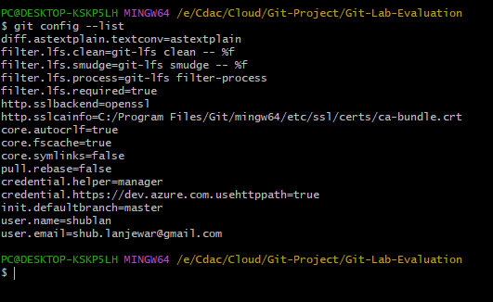

**Create a local git repository**

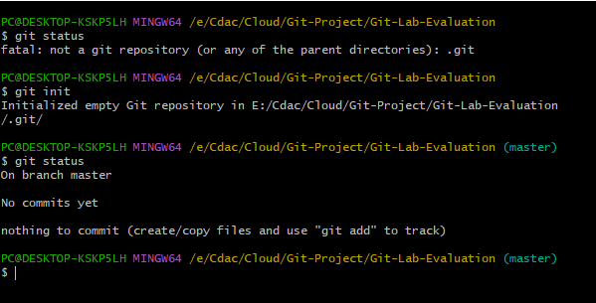

**Commit the initial code**

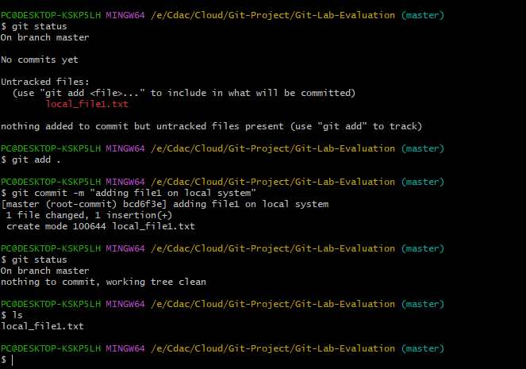

**Update  
the project on the remote server. Also perform some changes on remote n reflect the same on local.**

Git repository before pushing project to remote

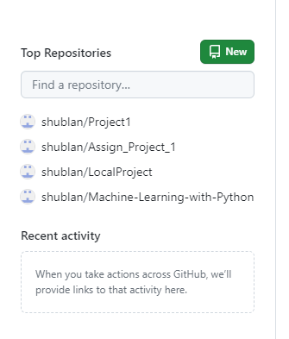

Pushing the project from local to remote :-

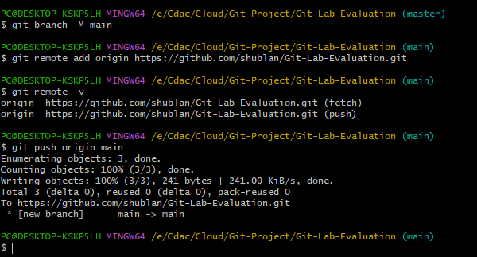

Git repository after pushing project to remote

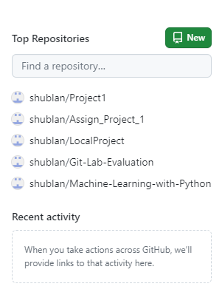

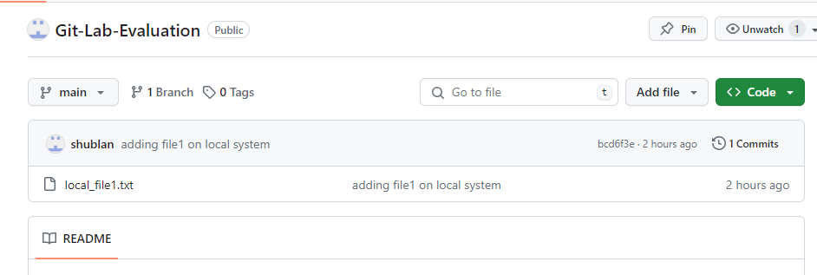

Making some changes on remote and reflecting the same on local :-

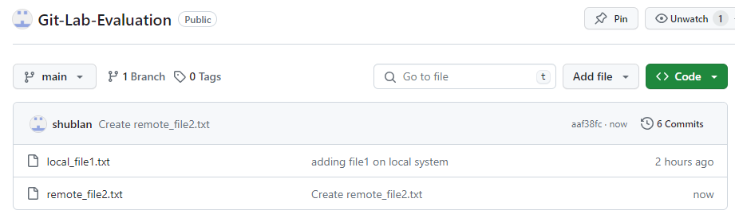

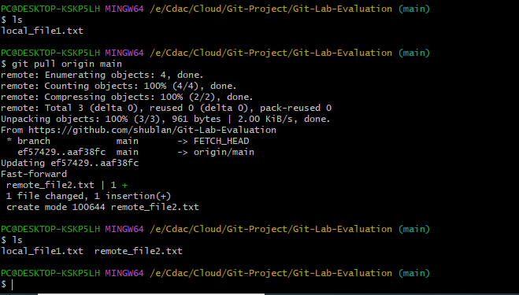

**Use  
git commands to**

**o Get the updated files**

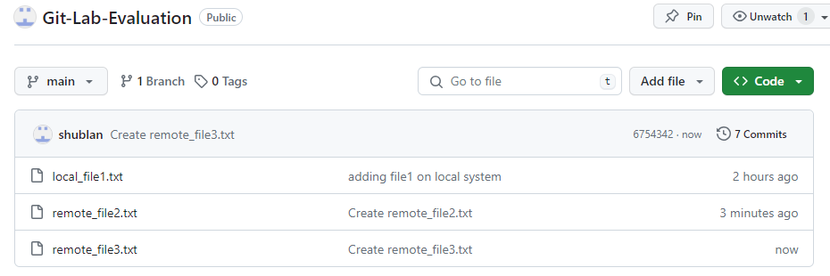

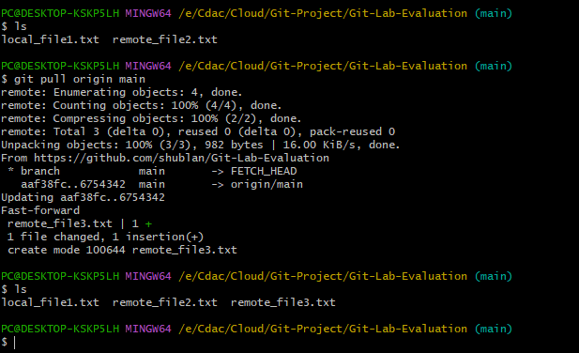  
  
  
**o List the changes**

before update :-

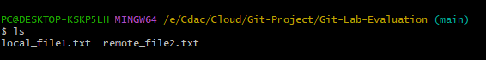

after update :-

git17

Showing the changes via git diff command:-

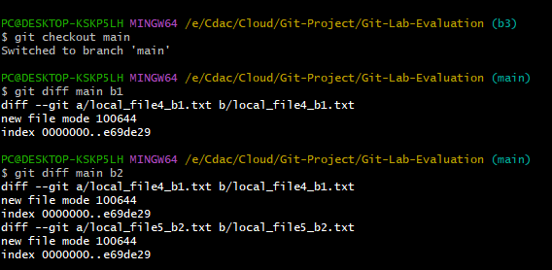  
  
  
**o Create branches  b1,>>b2,>>>b3  and update them as well.**

Creating branch b1 :-

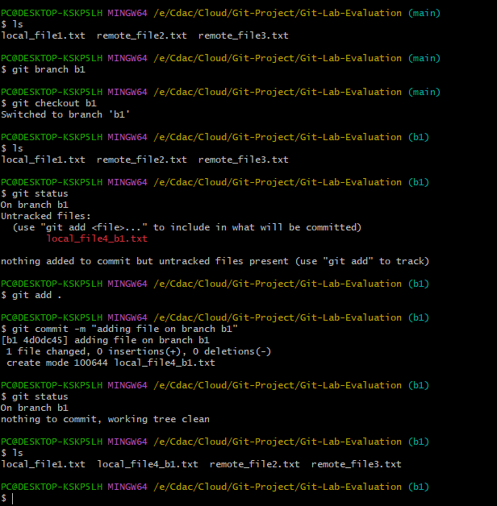

Creating branch b2 :-

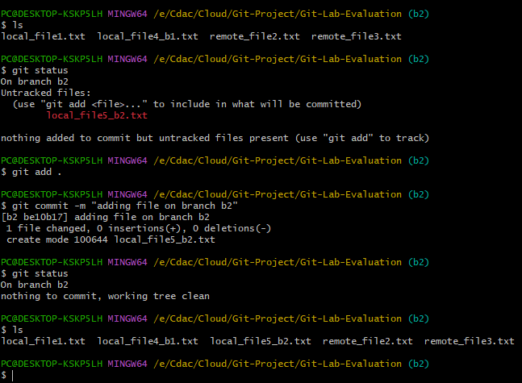

Creating branch b3 :-

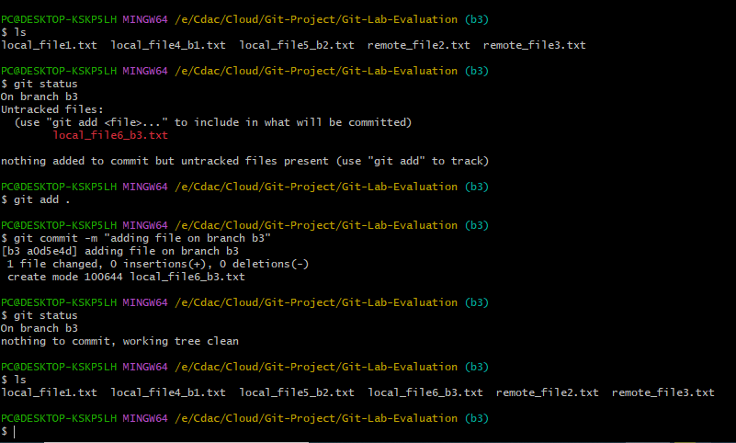  
  
**O List the changes**

Changes on branch b1

Before :-

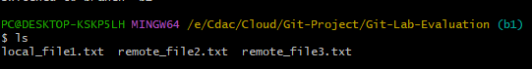

After :-

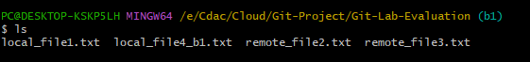

Changes on branch b2 :-

Before :-

git23

After :-

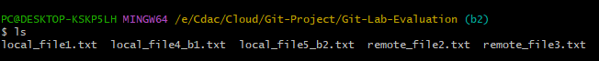

Changes on branch b3 :-

Before:-



After:-

git26

**Git log of branch main :-**

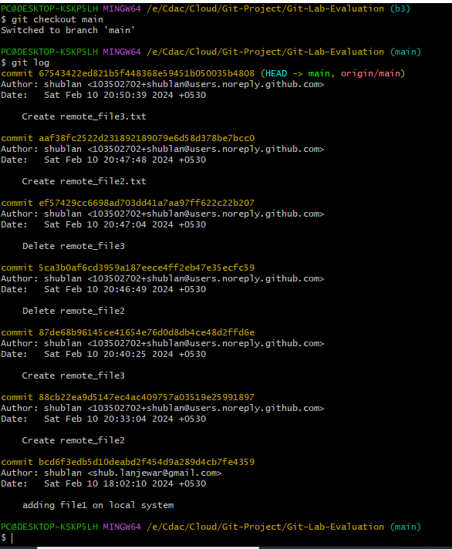

**Git log of branch b1 :-**

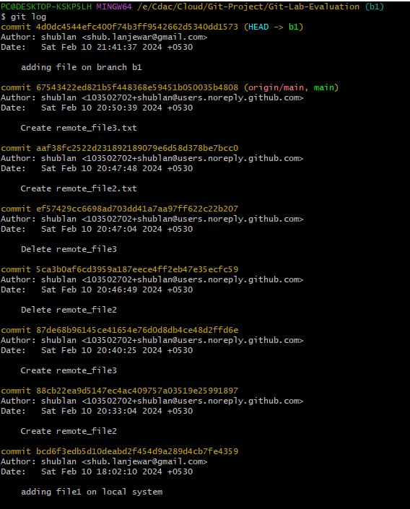

**Git log of branch b2 :-**

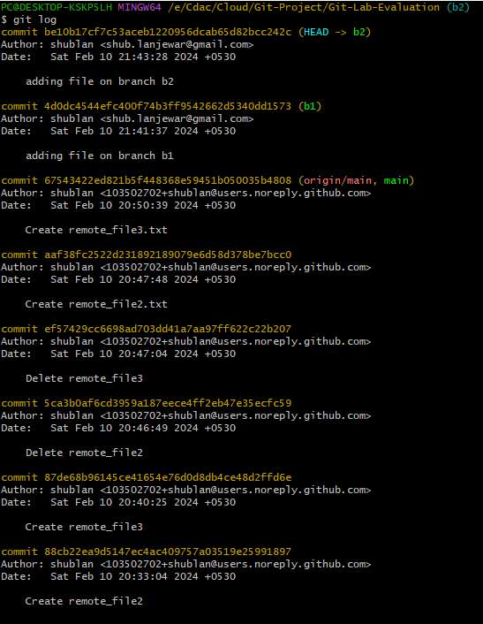

**Git log of branch b3 :-**

